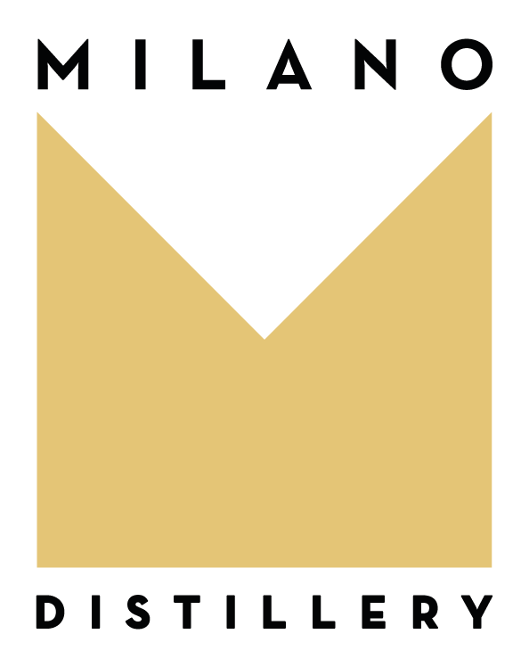

Press Release
A non-alcoholic distillate born in Milan, IMAGINE: the new way of drinking
Milan, March 1, 2023 – MILANO Distillery has launched IMAGINE, a made-in-Italy non-alcoholic distillate that defines a new way of drinking and brings innovation to the Beverage market. IMAGINE is also “the first alcohol-free drink of the metaverse” with the digital issue of 50 NFT of its label designed by the artist Antonio Colomboni.
The growing trend of non-alcoholic drink products today is not a constraint anymore, but it is a precise request coming from the desire of a better lifestyle and of an exciting drink taste like that of IMAGINE. This virtuous evolution path of consumers is clearly reflected in a growing non-alcoholic drink market worth $11 billion in its top 10 geographies (source 2022 IWSR).
IMAGINE is a distillate of high-quality natural botanicals worked separately and handcrafted with passion. Its scent is intense and broad with clear notes of juniper well balanced by the fresh citrusy notes of bergamot and the Mediterranean ones of sage and thyme. A rich and persistent taste that intrigues the palate with balsamic notes of ginger and chili pepper.
IMAGINE is the drink loved by those who want to fully experience the happiness of convivial moments. Its consumption is pleasant at any time, ideal for teenagers and teetotalers, for amateur and professional sportswomen and sportsmen. It is the perfect alternative when drinking is not allowed due to driving or pregnancy, or for those who want to avoid the “hangxiety” (hangover anxiety). It can be enjoyed alone OTR (on the rocks) or with a quality tonic and it is extremely versatile in mixology where it is able to enhance both alcoholic and non-alcoholic cocktails.
“We created IMAGINE not alone, but by sharing and "mixing" ourselves with important technical capabilities: the suggestions and nuances proposed by some Milanese Bartenders and Chefs, the wisdom of an expert Master Distiller, and the tradition of a discontinuous copper "MÜLLER Pot Stills" designed and engineered by Gianni Vittorio Capovilla, recognized as one of the best distillers in the world. From this skills’ mix, an excellent and exciting product was born, truly unique!” say Nico Losito and Valeria Morandi, Founders of MILANO Distillery.
In this new way of drinking, there is a lot of Italian innovation and creativity: recycled glass bottle, design packaging, uniquely numbered labels, blockchain-certified lot tracking and, above all, a new label concept: IMAGINE is art!
His label is not static but changes periodically: a "showcase" of artists who share the value of happy and sustainable conviviality. The labels of the first 3 lots were designed by the artist Antonio Colomboni (Milanese by adoption and Art Director of TOILETPAPER Magazine). IMAGINE is " the first alcohol-free drink of the metaverse"; since February, it is possible to buy, on Opensea, 50 NFTs of the Artwork on the label and/or 10 NFTs IMAGINE Bundles, very emotional and experiential phygital moments (physical + digital).
“The product is already used in several cocktail bars, it can be purchased online on imaginedrink.com, it is available in Europe on the Amazon channel and we are making it increasingly available on beverage distributors by all Italian bartenders. In the second half of the year, IMAGINE will land in international markets and in no-alcohol countries. As MILANO Distillery we are already working on a second non-alcoholic drink: a surprise for the city of Milan and for Italy. Stay tuned!” says Giorgio Morandi, General Manager of MILANO Distillery.

It may seem like a words pun with the term GIN, given that it can also be considered a zero-alcohol GIN, but in reality the name IMAGINE is evocative of the dreams and desires that each of us has, and it is as emotional and inspiring as the thought to create a better world, good and beautiful.

For further information:
MILANO Distillery Srl
+39 340 1824909
info@milanodistillery.com
www.imaginedrink.com
Instagram: @imagine.drink
NFT IMAGINE on https://opensea.io/MILANODistillery

